This is the Spring MVC example that explains the uses of RequestParam & Model in the Spring MVC application. The @RequestParam is used to read the HTML form data provided by a user and bind it to the request parameter. The Model contains the request data and provides it to the view page.
The @RequestParam annotation is used with @RequestMapping to bind a web request parameter to the parameter of the handler method.
The @RequestParam annotation can be used with or without a value. The value specifies the request param that needs to be mapped to the handler method parameter.
Reference Link:
https://dzone.com/articles/using-the-spring-requestmapping-annotation
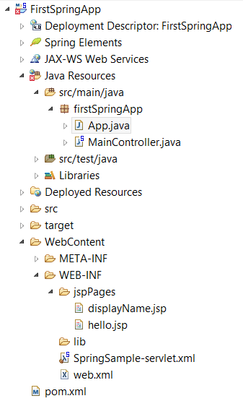
groupId: com.practice
artifactId: FirstSpringApp
web.xml
<!DOCTYPE web-app PUBLIC
"-//Sun Microsystems, Inc.//DTD Web Application 2.3//EN"
"http://java.sun.com/dtd/web-app_2_3.dtd" >

<web-app>
<display-name>Archetype Created Web Application</display-name>
<servlet>
<servlet-name>SpringSample</servlet-name>
<servlet-class>org.springframework.web.servlet.DispatcherServlet</servlet-class>
<init-param>
<param-name>contextConfigLocation</param-name>
<param-value>/WEB-INF/SpringSample-servlet.xml</param-value>
</init-param>
<load-on-startup>1</load-on-startup>
</servlet>

<servlet-mapping>
<servlet-name>SpringSample</servlet-name>
<url-pattern>/</url-pattern>
</servlet-mapping>
</web-app>
SpringSample-servlet.xml
<beans xmlns="http://www.springframework.org/schema/beans"
xmlns:context="http://www.springframework.org/schema/context"
xmlns:xsi="http://www.w3.org/2001/XMLSchema-instance"
xsi:schemaLocation="
http://www.springframework.org/schema/beans
http://www.springframework.org/schema/beans/spring-beans.xsd
http://www.springframework.org/schema/context
http://www.springframework.org/schema/context/spring-context.xsd">

<!-- Adding Support for Component Scan -->
<context:component-scan
base-package="firstSpringApp" />

<!-- Configure View Resolver -->
<bean
class="org.springframework.web.servlet.view.InternalResourceViewResolver">
<property name="prefix" value="/WEB-INF/jspPages/" />
<property name="suffix" value=".jsp" />
</bean>
</beans>
hello.jsp
<%@ page language="java" contentType="text/html; charset=ISO-8859-1"
pageEncoding="ISO-8859-1"%>
<!DOCTYPE html>
<html>
<head>
<meta charset="ISO-8859-1">
<title>Welcome Page</title>
</head>
<body>
Please enter your Name:
<form action="displayname">
<input type="text" name="firstName" /> <input type="submit"
value="Submit" />
</form>
</body>
</html>
displayName.jsp
<%@ page language="java" contentType="text/html; charset=ISO-8859-1"
pageEncoding="ISO-8859-1"%>
<!DOCTYPE html>
<html>
<head>
<%@ page isELIgnored="false" %>
<meta charset="ISO-8859-1">
<title>Display Name</title>
</head>
<body>Hello ${name}
</body>
</html>
MainController.java
package firstSpringApp;

import org.springframework.stereotype.Controller;
import org.springframework.ui.Model;
import org.springframework.web.bind.annotation.RequestMapping;
import org.springframework.web.bind.annotation.RequestMethod;
import org.springframework.web.bind.annotation.RequestParam;
@Controller
public class MainController {
@RequestMapping(value = "/", method = RequestMethod.GET)
public String welcome() {
return "hello";
}
@RequestMapping(value = "displayname")
public String displayName(@RequestParam("firstName") String firstName, Model model) {

model.addAttribute("name", firstName);
return "displayName";
}
}
App.java
package firstSpringApp;
public class App {
public static void main(String[] args) {
}
}

